

14 July 2022

**Terra Industrial New Zealand Ltd**

PO Box 16 168

16 Branston Street, Hornby

Christchurch 8441, New Zealand

03 983 2333 Tel

www.TerraCat.co.nz

**Fix items on bank reconciliation screen**

**To fix items on the bank reconciliation screen that don’t get fixed by the unreconciled screen. These items are usually deposits.**

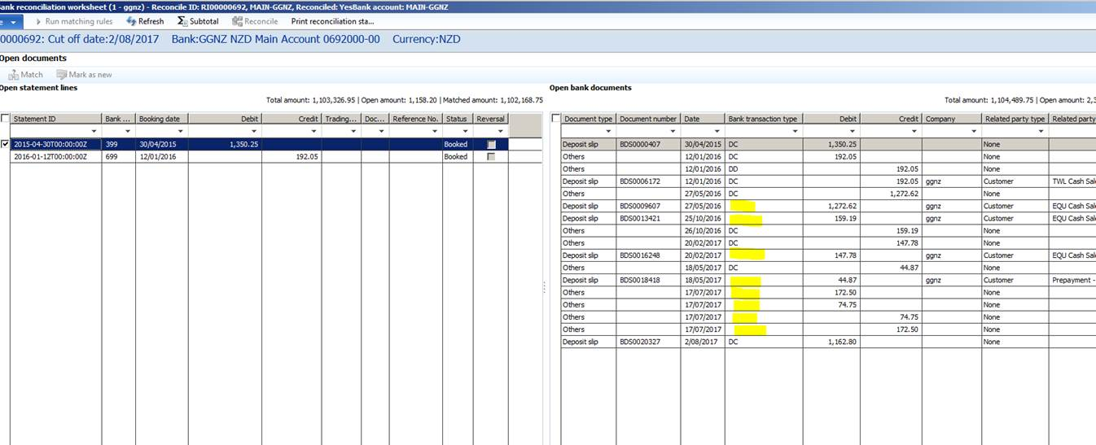

Open NAXT

Go to Cash & Bank Management – Common - Deposit Slip

Right click on the bank account field – Personalise

On Information Tab, click Edit by Form Name

Click on Data Sources

Highlight BankDeposit, Right click – Add-Ins – Table Browser

Ctrl G

In Account ID filter MAIN* - Bank TransType “ (for Blanks)

Find the ones you need to change and put in the correct Bank Transaction Type that Anara has advised, eg DC

Once finish close screen

**To Update Bank Deposit Document table**

In AX go Ctrl D (the Application Object Tree) will open, click Data Dictionary, click on Tables

Find BankDepositDocument table

Right click – Add Ins – Table Browser

Ctrl G

In Account ID filter MAIN* - Bank TransType “ (for Blanks)

Find the ones you need to change and put in the correct Bank Transaction Type that Anara has advised, eg DC

Once Finished Close screen

Go into bank reconciliation screen and see if the items have a value of DC now and can be reconciled.

